Day 3 Assignment

HelpDesk Lite - From Jira Workspace to AI-Assisted Engineering Workflow.

- Mapping AI task

Jira Task | AI support | Reason
Employee submits a support ticket | Partial | AI can generate API code and validation logic, but the developer reviews the business rules.
Manager assigns ticket | Partial | AI can suggest implementation, while assignment rules are verified by the developer.
Agent views assigned tickets | Yes | AI can help generate UI components and API queries.
Agent updates ticket status | Partial | AI assists with code generation, but status transitions must be tested.
Employee tracks ticket status | Yes | AI can generate tracking logic, documentation, and unit tests.

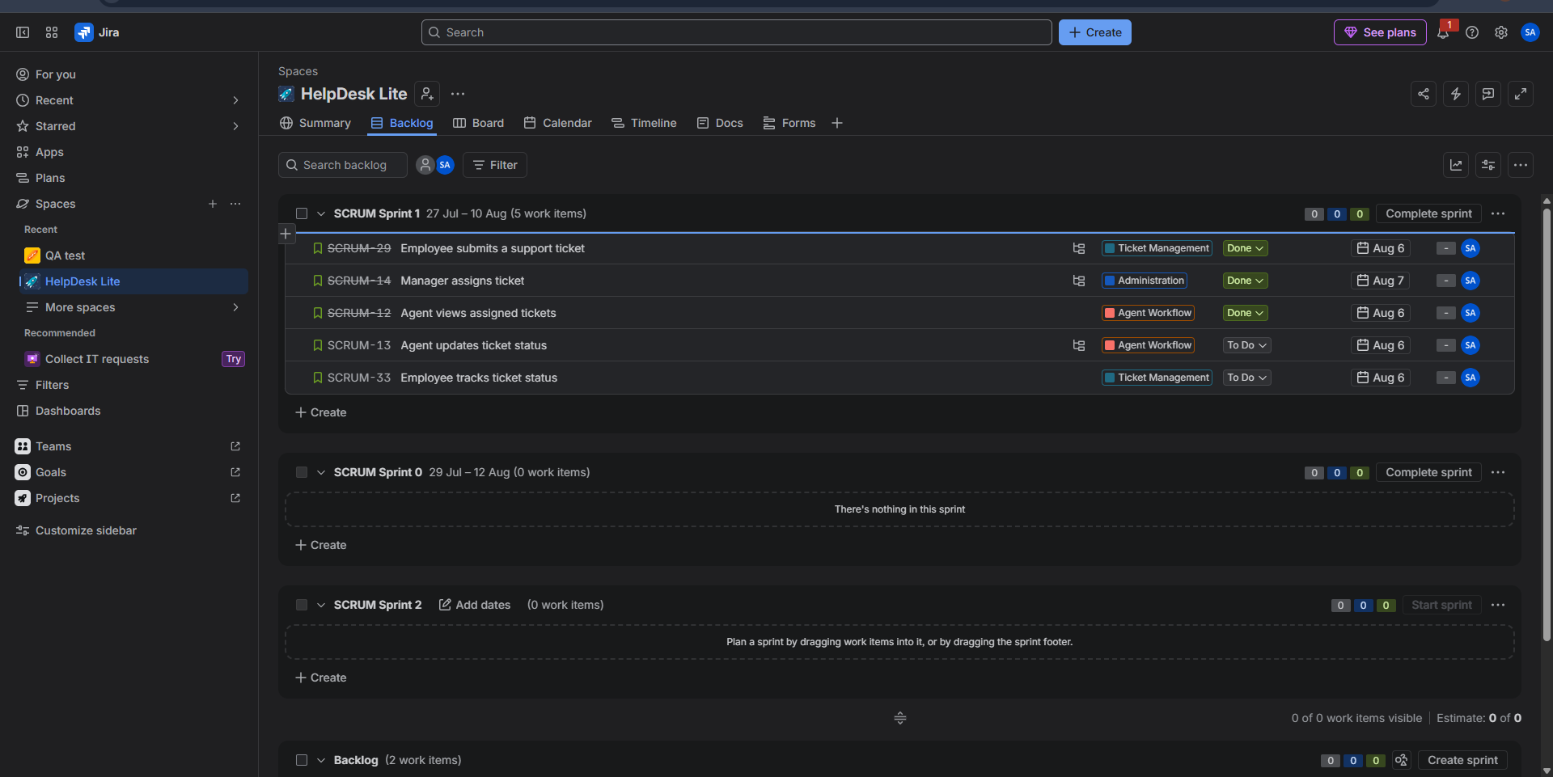

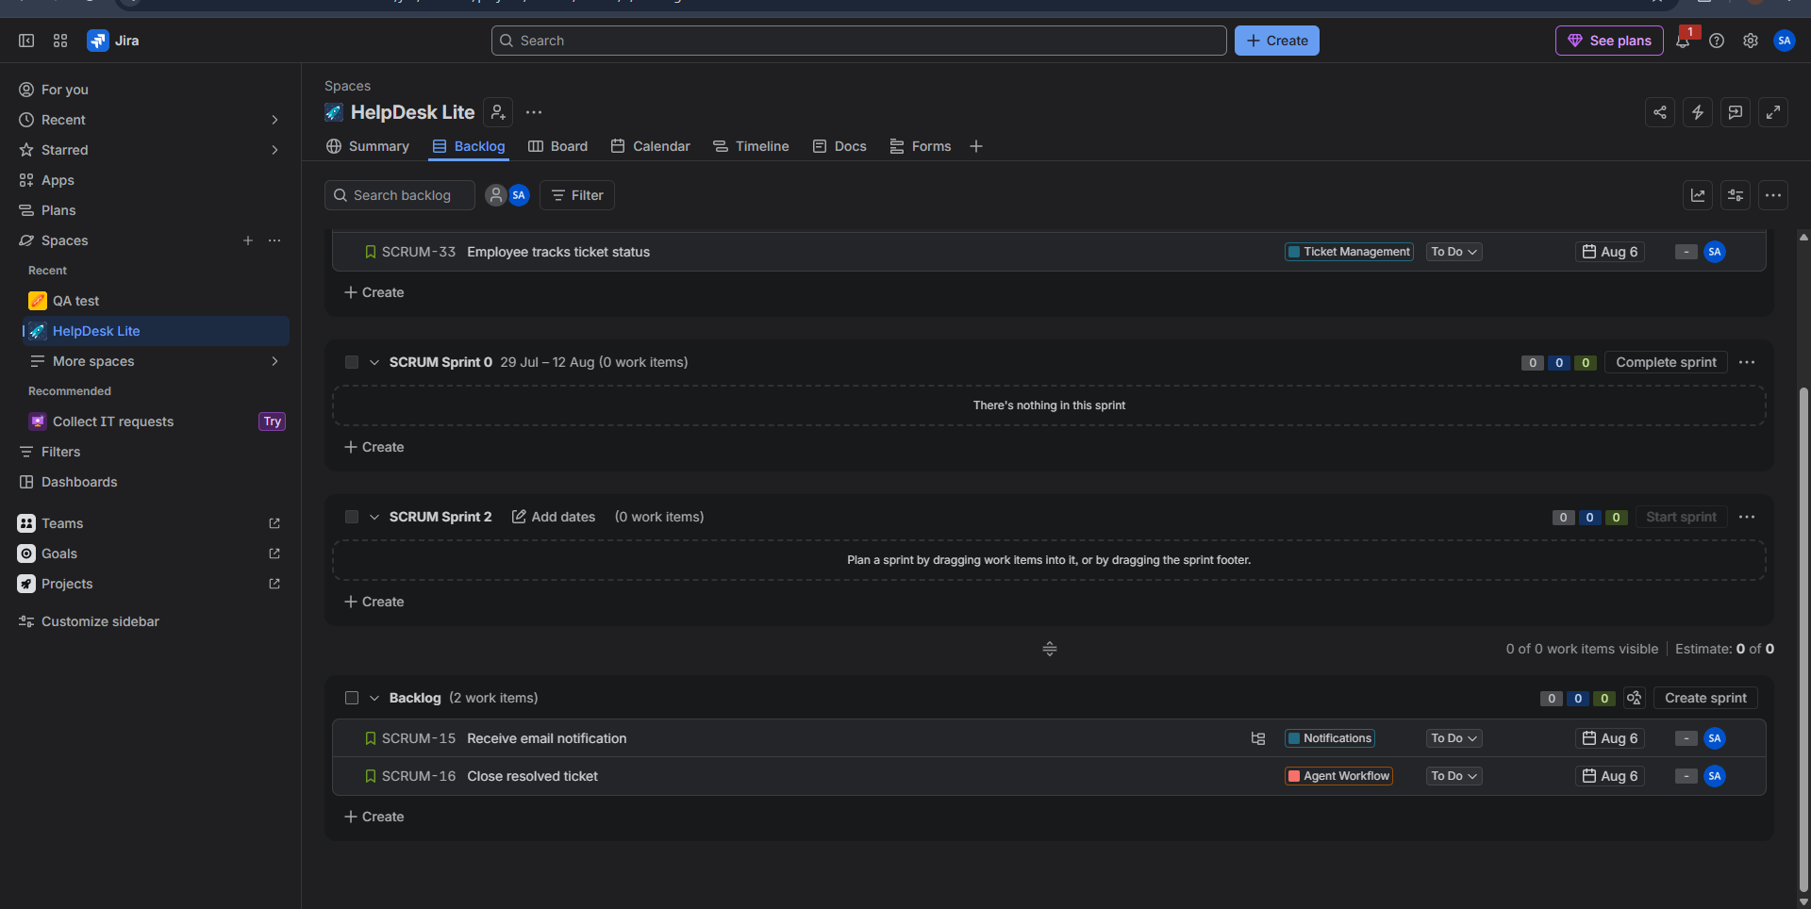

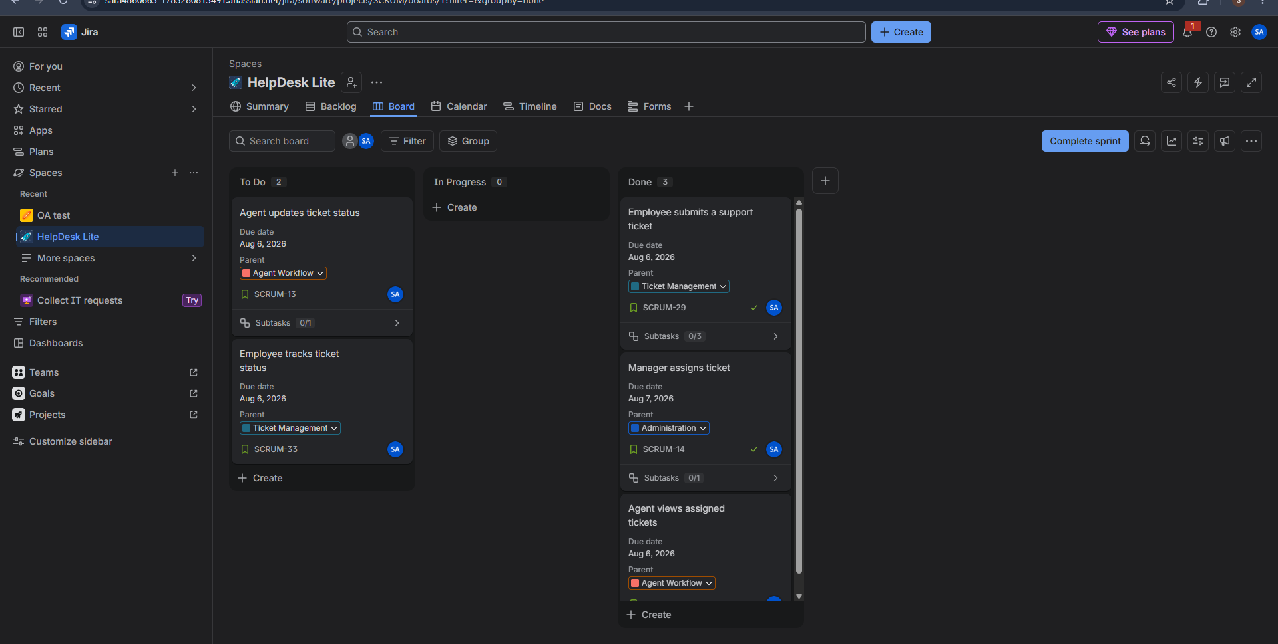

- Context and Access Plan

Task | AI Access
Code generation | Relevant file only
Bug fixing | Error log + related file
Documentation | Related module only
Unit testing | Function or module under test
Code review | Pull request diff only

3)AI Coding Workflow 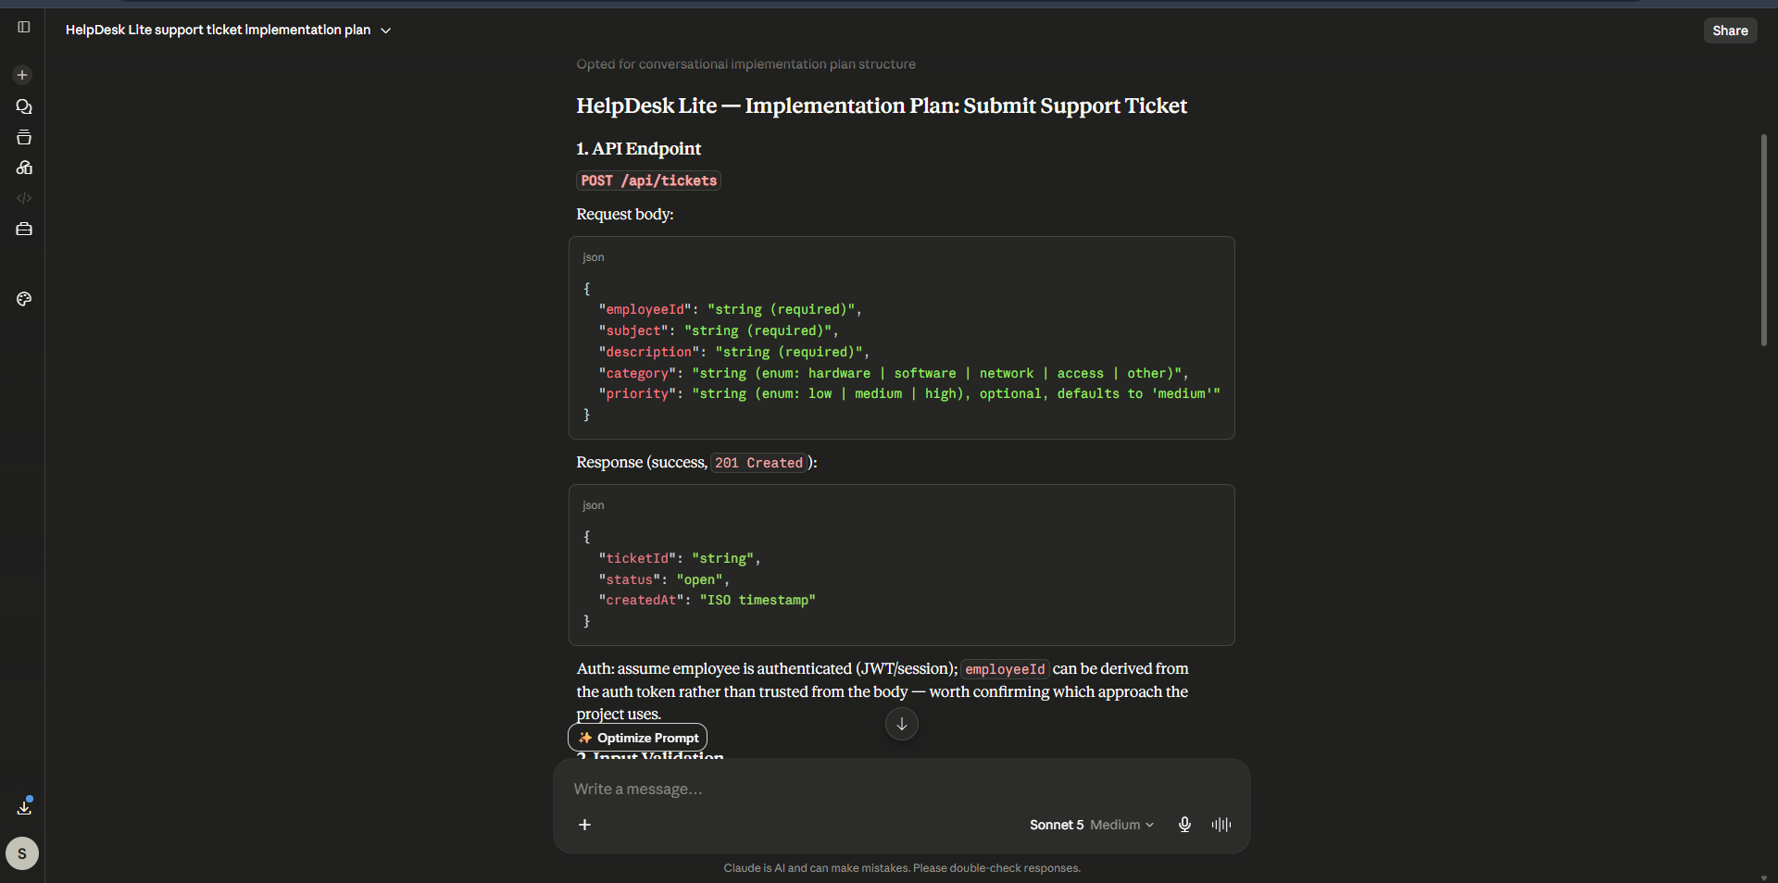

Figure 1: Claude AI was used to generate an implementation plan for the "Submit Support Ticket" feature before writing any code. This helps ensure the development process follows a plan-first approach.

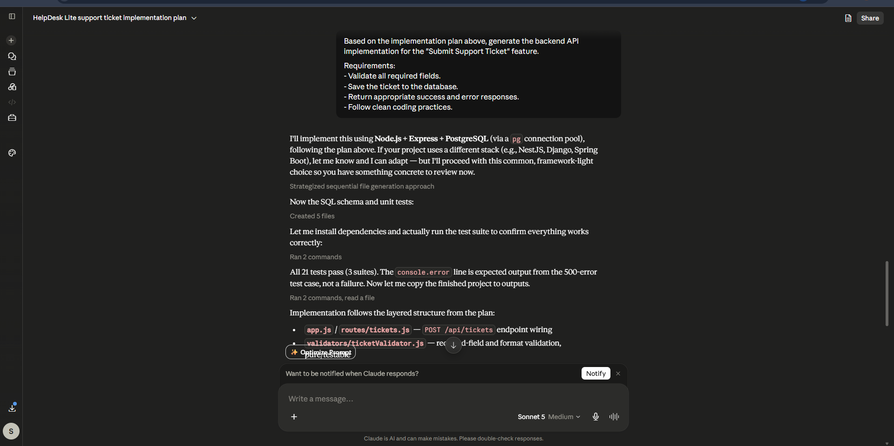
Figure 2: After reviewing the implementation plan, Claude AI was asked to generate the backend implementation. The generated output was reviewed before acceptance to ensure it met the project requirements.
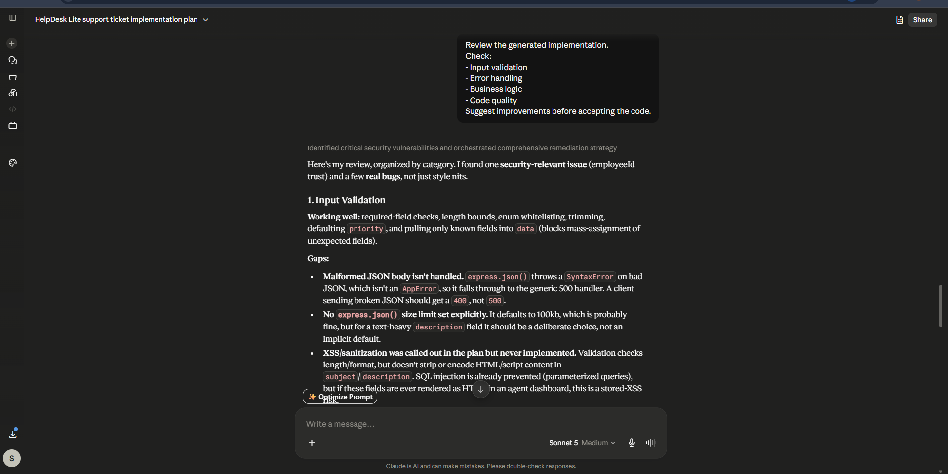

Finally, Claude AI reviewed the generated implementation by checking input validation, error handling, business logic, and code quality before accepting the solution.

4)

Debugging.
Bug:
The employee submits a ticket, but it is not saved.
Investigation:
- Check logs.
- Check API response.
- Check database.
Decision:
Revise the AI suggestion only after testing.

5)

Tool | Official Documentation
ChatGPT | OpenAI
Cursor | Cursor Docs
Claude | Anthropic Docs

